**Digital Narture Deep Skilling**

Week 1 - Design Principles And Patterns

**RAJAKUMAR S**

**727822TUEC144**

**SUPERSET ID: 6373997**

**Exercise 1: Implementing the Singleton Pattern**

public class Logger {

    private static Logger instance;

    private Logger() {

        System.out.println("Logger instance created.");

    }

    public static Logger getInstance() {

        if (instance == null) {

            instance = new Logger();

        }

        return instance;

    }

    public void log(String message) {

        System.out.println("LOG: " + message);

    }

}

public class SingletonTest {

    public static void main(String[] args) {

        Logger logger1 = Logger.getInstance();

        logger1.log("First log message");

        Logger logger2 = Logger.getInstance();

        logger2.log("Second log message");

        if (logger1 == logger2) {

            System.out.println("Both logger1 and logger2 are the same instance.");

        } else {

            System.out.println("Different instances exist — Singleton failed!");

        }

    }

}

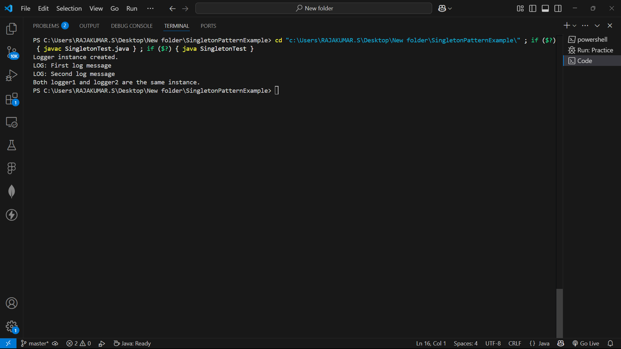

**Exercise 2: Implementing the Factory Method Pattern**

interface Document {

void openDocument();

}

class WordDocument implements Document {

public void openDocument() {

System.out.println("Word Document is now open.");

}

}

class PdfDocument implements Document {

public void openDocument() {

System.out.println("PDF Document is now open.");

}

}

class ExcelDocument implements Document {

public void openDocument() {

System.out.println("Excel Document is now open.");

}

}

abstract class DocumentFactory {

public abstract Document createDocument();

}

class WordDocumentFactory extends DocumentFactory {

public Document createDocument() {

return new WordDocument();

}

}

class PdfDocumentFactory extends DocumentFactory {

public Document createDocument() {

return new PdfDocument();

}

}

class ExcelDocumentFactory extends DocumentFactory {

public Document createDocument() {

return new ExcelDocument();

}

}

public class FactoryMethodPattern {

public static void main(String[] args) {

DocumentFactory wordFactory = new WordDocumentFactory();

Document wordDoc = wordFactory.createDocument();

wordDoc.openDocument();

DocumentFactory pdfFactory = new PdfDocumentFactory();

Document pdfDoc = pdfFactory.createDocument();

pdfDoc.openDocument();

DocumentFactory excelFactory = new ExcelDocumentFactory();

Document excelDoc = excelFactory.createDocument();

excelDoc.openDocument();

}

}

